 St Patrick’s P.S.

and Nursery

Castlederg



**73 Castlefin Rd**

**Castlederg**

**Co Tyrone BT81 7EE**

**Tel 028816 71458 Fax 028816 79821 email:info@stpatricks.castlederg.ni.sch.uk**

**Website –** [www.stpatrickspscastlederg.co.uk](http://www.stpatrickspscastlederg.co.uk)

**January/February 2019 Newsletter**

**online @** [www.stpatrickspscastlederg.co.uk](http://www.stpatrickspscastlederg.co.uk)

Welcome back to a new term – In line with the Department of Education NI, this year we will moving to an online newsletter.

**Parent Support Group and all Parents.**

On behalf of the staff, pupils and governors I wish to thank the Parents Committee for the help and support they have provided this year and for the recent donation of £4000. The reality is that without the money raised by parents these essential items would have to be sourced from other parts of the school budget at the expense of the teaching and learning of the pupils.

 The money donated this week will be used to - Replenish Maths Books and Equipment, Upgrade 4 Interactive Class Whiteboards and install 1 new set of speakers, Supply Classroom Tables and Chairs and assist with a Creative Writing Project this term in year 4 and 5 at a total cost of £5500.

Many thanks for your support for the non-uniform for children’s cancer services last term. £1140 was shared evenly for Clic Sargent NI and NI Children’s Cancer Unit Charity RVH. Our Christmas jumper day raised £273 for Trocaire’s Yemen appeal. A lot of fundraising but for worthy causes – well done!

**Catholic Schools Week**



This year’s theme is Catholic Schools – Catholic Schools Week 2019 will run from 27th

January to 3rd February 2019. The theme for Catholic Schools Week this year is Catholic

Schools: Celebrating the Work of Our Local Catholic Schools. Throughout this week our pupils will learn about Living Tradition, Welcoming Diversity, Grandparents Day, In Service of our Community and Supporting Faith

A special mass for pupils in P4 to P7 to celebrate the work of our school will take place onFriday 1st February 2019 at 10am in St. Patrick’s Church. Weather Dependant*

Please note that applications and documents for P1 and nursery must be completed online by the 31st January 2019.

Late applications cannot be considered until all other children are placed. Make sure all family members are informed.

**Meet Our Pupil Council 2019**

This is the 5th year of our Pupil Council. Our elected representatives are Ryan, Oisin Lucy and Eimhear P7, Eimear and Martha P6 and Niamh, Dana, Eadaoin and Farrah P5. The Pupil Councillors meet with their classes to discuss issues affecting them – and report back to Mrs. Norton and Mr. Mc Gurk. They keep minutes of meetings and learn how a school council works and operates. Their opinions are valued by their classmates and by the staff. They hope to run competitions and discussions among their classmates.

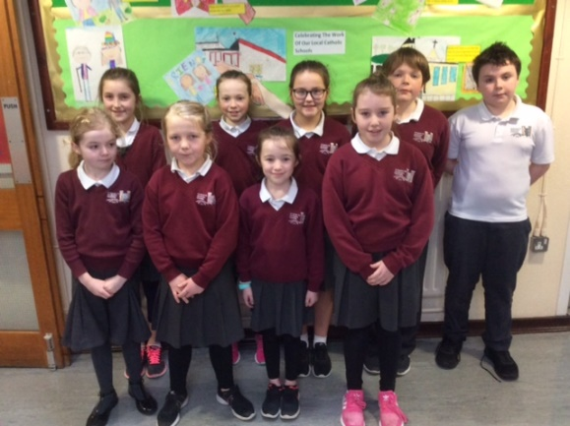

**World Book Day** takes place on Thursday 7th March 2019 so there be lots of opportunity for reading and storytelling during this week. Why don’t you make a special effort to visit the library this week or encourage the pupils to read during the month of March 2019. There are lots of activities and ideas on World Book Day Website - <https://www.worldbookday.com/>



‘The child who learns to read while sitting in Mum or Dad’s* lap will become a lifelong learner.’ – Bruce Perry

 **Spelling Bee Competition**

Mrs. Mc Erlean will be organising our annual spelling bee competition during March 2019 so children get practising.

**Extended Schools Spring Term 2018**

Breakfast club continues as normal each morning.

Sports clubs and a Music Club will resume in February.

* Homework Club Monday to Thursday 3.15pm – 4.30pm Cost £2 Daily.

Any changes or reasons for attendance should be recorded in the pupils reading record or homework diaries and the pupils can bring it to the attention of their teacher. Thank you.



**Safer Internet Day 9th February 2019.**

The school has participated in Internet Safety Day/Safer Internet Day since its start in 2011. This year we while be focussing on the use of social media and the amount of screen time that children and adults use their phones and technology. The average adult touches their phone/device 2,617 every day (Disrupted Childhood 2018) – think about the amount of time lost to children each day and the message children take from this.

Increasingly I am having to deal with issues involving social media – we always teach our older pupils that everything we post, say or search online is discoverable.

Further advice on online safety and tips for parents can be found at

<https://www.saferinternet.org.uk/advice-centre/parents-and-carers>

I ll include this link and pupil links on our school website. We also post monthly online safety newsletters which are designed to help parents understand and keep their children safe online. Remember it’s good to discuss with your child their internet use and to help them learn how to be safe.

The **NSPCC** will visit the primary school on the 14th February 2019 and complete classroom activities and talk to the children about personal safety as part of the ‘Speak Out Stay Safe Campaign’. P7 Pupils will also take part in Workshops entitled ‘What’s Inside’ as part of the RSE Programme on the 1st March 2019.

**Paired Reading Programme.**

Mrs. Mc Glade and Mrs. Gallagher’s P3 classes are taking part in a paired reading programme from the beginning of February. More information is available on our school website.



**Gaelic games/sports**

The P7 hurling and camogie teams competed in the Tyrone indoor heats in Omagh this week.

The boys and girls football teams will compete in the Tyrone indoor gaelic competition in February and March 2019.

The P7 pupils will commence a ten week block of swimming lessons this week in swimming Riversdale Leisure Centre Strabane.

**Transfer Forms**

Transfer forms will be sent home this week with the P7 pupils, these have to be completed and returned to school by Tuesday 5th February 2019. If any parent wishes to arrange a meeting to discuss their choice of schools – please contact me at the numbers above.

**Healthy Snacks and lunch boxes**

As a health promoting school please include healthy foods in the children’s lunchboxes, also a reminder not to include nut products Please remember that only healthy snacks can be eaten at break time, no chocolate or cereal bars, sweets or sugary yoghurts or drinks at break please. Your support is greatly appreciated.

**Midterm Holiday**

The school will be closed for the midterm break on Friday 15th February, Monday 18th February and Tuesday 19th February 2018.

The school will be closed for St Patrick’s Holidays on Monday 18th March 2019.

**Road Safety **

Thank you to all parent/s who park safely and who show care and consideration when dropping or collecting the pupils from school. Please avoid double parking as this causes a build-up of traffic and is dangerous for pupils at collection time. Please remember to keep clear disabled spaces and bus bays. Please remember to use only the main pedestrian gate to enter and exit the school.

Many thanks

Brian Mc Gurk Principal