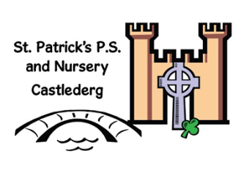

Online Safety Newsletter: May 2019

Roblox
Let’s Talk Online Safety

Having regular conversations with your child about their online life is so important. If you show an interest then they are more likely to come to you if they have a problem. Here are a list of questions to start with:

1. What games/apps are you playing?
2. Can I play this game/app with you?
3. Do you have any online friends?
4. What would you do if you saw something upsetting online?
5. Do you understand what private information is?

This is a great document about talking to your child about healthy internet use:
https://www.mentalhealth.org.uk/sites/default/files/Talking-to-kids-healthy-internet-use.pdf

PEGI have rated Roblox a PEGI 7 due to frequent scenes of mild violence and scenes which younger children may find frightening. It is not suitable for persons under 7 years of age.

Roblox gives players the opportunity to play, build and create games and now has over 90 million monthly active users. Is your child one of them? It is available on PC, Mac, iOS, Android, Amazon Devices and Xbox One.

What should I be aware of?
Chat Facility
Players can chat to each other, however for players under 12, this feature can be turned off completely or restricted to friends only (although do they (you) know all of their accepted friends?). Players age 12 and younger do have their posts and chats filtered both for inappropriate content and behaviour and to prevent personal information from being posted.

Blocking users and reporting abuse
Roblox offers the ability to block users so as with all games your child plays, ensure they know how to block users that may be harassing or bullying them.

Virtual Currency
Roblox is free to download and free to play. Players can however buy Robux (their virtual currency) to buy in-game upgrades or accessories. If you do not want your child to purchase them ensure your card details are not saved.

Account PINs
You can set up a 4 digit Account PIN to stop your child making any changes that you’ve set to the account.
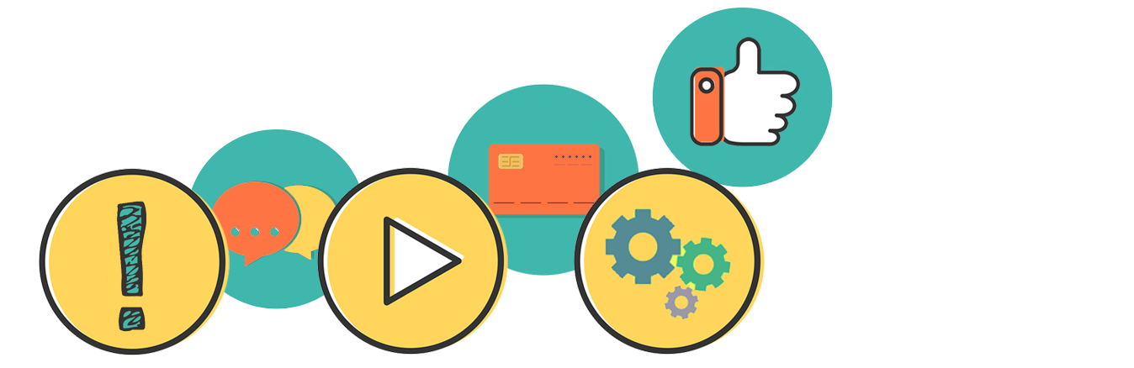
More information
https://en.help.roblox.com/hc/en-us/categories/200213830-Parents-Safety-and-Moderation

SnapChat (age 13+)
Sharenting (using social media to share information about your child)

Place2Be and law firm Mishcon de Reya have worked together to produce three films exploring children's views on sharenting. The ‘sharenting’ films feature children age 9 to 11 years who give their advice to parents on how best to protect their children when sharing content online. As the films show, the internet has a very long memory and includes useful tips such as checking your security settings so you are only sharing with people you know. https://www.place2be.org.uk/our-story/news/place2be-and-mishcon-de-reya-launch-films-to-explore-sharenting.aspx

CBBC and Pop Stars ‘Max and Harvey’ have also produced their five social media rules for parents: https://www.bbc.com/ownit/its-personal/max-and-harvey-social-media-rules

Snapchat is a messaging app used to send photos, videos, text and drawings (called snaps) which disappear after they've been viewed. You should be 13+ to sign up. If you choose to allow your child to have an account then you should be aware of the following:

Snap Map (sharing their location)
The Map lets users see where their friends are if a friend has chosen to share their location at any given time. Location sharing with friends via the Map is optional and is off by default (we recommend that this remains the default setting).

Snapchat streaks
Streaks count how many consecutive days two people have been sending Snaps to each other. A streak is shown by a little picture of a flame and a number (the number of days the streaks has gone on for) next to a contact’s name. There can be pressure to respond on a daily basis to maintain their streaks and it can cause issues with people logging into other’s account to carry on streaks for friends.

Reporting

Ensure your child knows how to report any issues when using Snapchat. Users are able to report within Snapchat stories, report a Snap they’ve received, an account, remove and block a ‘friend’.

Safety tips and resources
It’s really important to talk to your child regularly and make sure that they know that you’re always there to talk to if they have any concerns. Snapchat have produced this really useful Parent guide with Connect Safely: https://storage.googleapis.com/sc-support-web/safety/parents-guide-en.pdf and have their own safety centre accessed here https://www.snap.com/en-GB/safety/safety-center/ .
Slang terms used playing online games

L2P – Learn to play, usually used negatively to describe players who aren’t very good.
Noob – newbie, usually means not very good at the game.
Pwned - means being owned (losing an argument).
FTW – For the win.

