To access Accelerated Reader use this link:
https://ukhosted49.renlearn.co.uk/2235117

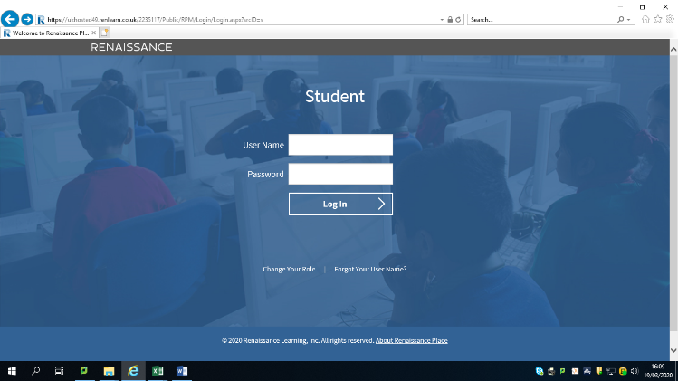
Using the username and password log on to the site

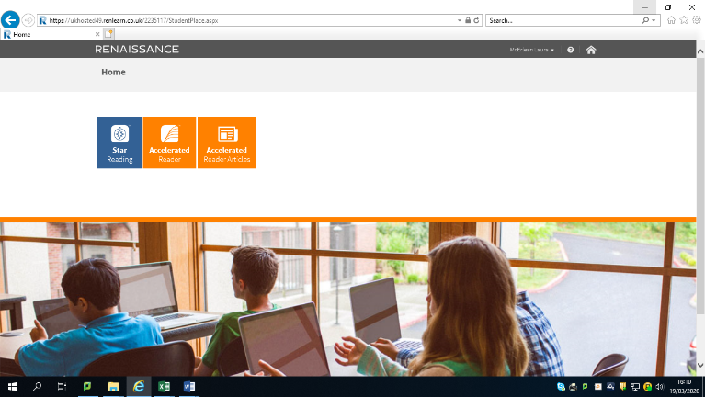

Click on the middle box Accelerated Reader

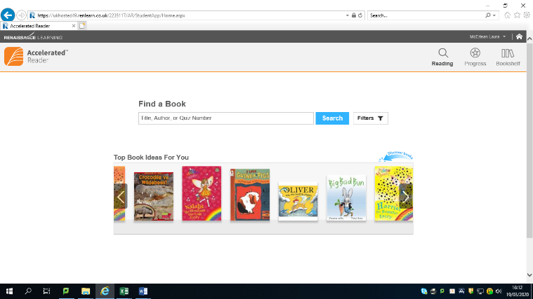

Click in the box called Find a Book .
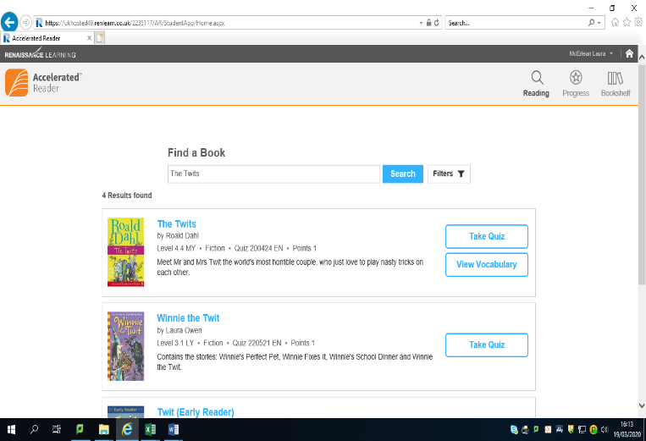
Type the name of the book you have read
Select the book and click on Take a Quiz

