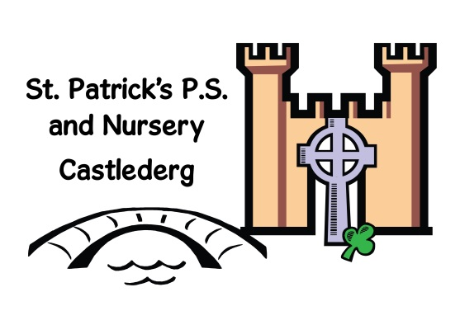

Online Safety Newsletter

April 2020

The Digital Family Pledge
This is a free online tool from Vodafone to help you as a family set good digital habits.
The Pledge covers four important topics: screen time, online bullying, social media and gaming. It uses a series of quiz like questions to prompt families to discuss and agree some rules on how to use technology and act online. It is aimed at families with children who are aged 5-13 years.
The pledge is best completed on a mobile or tablet and together as a family. The pledge is available here: www.vodafone.co.uk/familypledge

Learning online at home

As many more of us will be at home and perhaps with increased screen time we need to make sure we maintain open and regular conversations with our children about what they are doing online and who they are interacting with. Set clear rules for them. Here are a few websites providing free content that may help over the coming weeks.

Literacy Trust

Split by age group, from birth to aged 12, this website includes ideas and guidance for simple activities to engage your child whilst benefiting their reading, writing and language development.

https://literacytrust.org.uk/family-zone/

Edinburgh Zoo

Watch some of the animals live at Edinburgh Zoo through their live cams:

https://www.edinburghzoo.org.uk/webcams/panda-cam/

White Rose Maths

White Rose Maths Team has prepared a series of five maths lessons for each year group from Year 1-8

https://whiterosemaths.com/homelearning/

Phonics Play

Phonicsplay have made their website free to use during this period.

https://www.phonicsplay.co.uk/

Looking for apps?
This is a great website that allows you to filter your search results to find age appropriate apps for your child. It also allows you to filter by app type (educational or play), by price and device:
https://www.goodplayguide.com/good-app-guide/

Twinkl

Twinkl have created home learning and school closure packs for free.

https://www.twinkl.co.uk/resources/covid19-school-closures

Hour of Code

Try a one-hour tutorial designed for all ages

https://hourofcode.com/uk

Users of this guide do so at their own discretion. No liability is entered into. Current as of the date released 1.4.20.

Tik Tok challenges

Tik Tok (along with other apps) can be used for social media challenges, lots can be fun but some can be dangerous.

We do not recommend talking to your child about specific challenges (it draws attention to them) but we do recommend talking to your child about challenges as a whole that may appear on the internet and making sure they know that they can talk to you about what they see online. Talk to them about the potential risks that may arise from participating in such challenges.

It is so important to have regular chats with your child about their online life and if they are experiencing peer pressure.

Further information:
https://www.saferinternet.org.uk/blog/online-challenges-and-peer-pressure

Information
Instagram
Instagram is used to post photos and videos. Users can also DM (direct message), send disappearing messages, add to their stories (these disappear after 24 hours) and broadcast using IGTV. You should be over 13 years of age to set up an account. To create an account you must enter a date of birth (but this isn’t verified).

Account Privacy

When you set up your account, it is automatically set as public. This means that anybody can see what you share. We would recommend changing this to private so only those your child approves to follow them can see their content. To change a profile to private go to profile, tap Settings, tap Privacy, tap Account Privacy and tap to toggle Private Account on.

IMPORTANT: Even if your child has set their Instagram profile to private, your child’s bio (at the top of their profile) can still be seen by everyone. Check they’ve not included any personal information in their photo and bio info (e.g. they should not be wearing their school uniform in their photo).

Other additional privacy settings include:
Online Safety with under 5s
There is a charge for this book.

Childine have released a new online safety themed learning to read book, ‘Aimee and the tablet’.

It is aimed at 4 and 5-year olds and helps teach young children what to do if something strange or upsetting happens online as well as helping parents to start conversations early with their child. More information available here:

https://www.childnet.com/blog/explore-online-safety-with-under-5s-with-our-new-learning-to-read-book

- Story control – either set allow message replies from ‘your followers’, ‘followers you follow back’ or turn off.
- Don’t allow sharing of your photos and videos from your story.
- Comment Controls – select hide offensive comments.

Make sure your child understands that there is a risk that content they upload can never be removed (other users can screenshot it for example) so they must only share content that they are comfortable with you seeing.
Safety Features

Ensure your child knows how to report posts and people as well as how to unfollow and block people, delete and turn off comments. More information can be found here: https://wellbeing.instagram.com/safety.
You are also able to report photos, videos, comments or profiles that are bullying or harassing via Instagram’s help centre.

#OnlineSafetyAtHome

ThinkuKnow have created a special area to support parents during COVID-19 and the closure of schools. Every fortnight, they will be releasing new home activity packs with simple 15 minute activities you can do with your child to support their online safety. The packs are split into the following age groups:

- 4-5s
- 5-7s
- 8-10s
- 11-13s
- 14+
You can download your packs here:

https://www.thinkuknow.co.uk/parents/support-tools/home-activity-worksheets

Inappropriate Content

There are public accounts on Instagram that can include graphic content and therefore your child may come across inappropriate content as well as language. Ensure that your child knows that they should talk to you or another trusted adult if they have any concerns.

Restrict mode

This feature allows users to restrict another user. You could restrict somebody (a bully for example) which means they will not be able to see when you are online or if you’ve read their messages. Also, only you (and that user) will be able to see their comments on your post. The great thing about this feature is that they won’t know that you have ‘restricted’ them. This is different to blocking (when you block somebody, you no longer see anything they do on Instagram and they don’t see anything you do either). Learn how to use this new feature so you can show your child how to use it: https://help.instagram.com/2638385956221960

Need more help?

Childnet answer parents most frequently asked questions here:

https://www.childnet.com/blog/answering-parents-most-frequently-asked-questions-about-instagram

Additional Links

- https://www.saferinternet.org.uk/advice-centre/social-media-guides/instagram
Improve your Privacy online

This article contains advice for you about improving your privacy online:

https://www.saferinternet.org.uk/blog/improve-your-privacy-online-advice-parents-and-professionals

- https://www.internetmatters.org/resources/instagram-safety-a-how-to-guide-for-parents/
- https://help.instagram.com/116024195217477/?helpref=hc_fnav&bc[0]=Instagram%20Help&bc[1]=Privacy%20and%20Safety%20Center
- https://www.net-aware.org.uk/networks/instagram/

Ensure that your child knows that they should talk to you or another trusted adult if they have any concerns.

