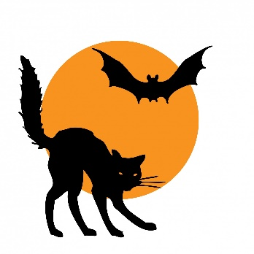
NEWSLETTER

St Patrick’s Nursery Unit October 2021
Theme: Autumn / Halloween
Colour: Autumn Colours; Orange, Red, Brown, Yellow and Black for the end of the month.
Rhymes and Songs
- Incy Wincy Spider
- Little Miss Muffet
- Peter Peter Pumpkin Eater
- The Witches of Halloween
- Hagalena Magalena

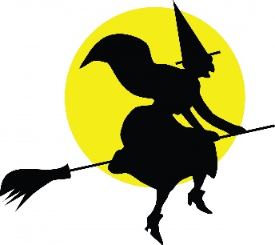
Dressing up Day
The children can all come in on Tuesday 26th October in their Halloween fancy dress costumes. It is advisable that accessories such as broomsticks, magic wands, swords and masks are NOT sent into nursery.

Mid Term Break
The Nursery will be closed from Tuesday 26th October to Tuesday 2nd November.

Birthday Greetings October
This Photo by Unknown Author is licensed under CC BY-NC-ND
Luca Floyd – 15th Oct
Chloe Crees – 21st Oct
Lochlann McCrory – 30th Oct

Settling in

All the children have settled in so well. We are very proud with how they have coped coming into nursery. Well Done!

Autumn Theme
We will have a table for autumn objects in the nursery and I would like this to be replicated in the home in some way. Take a walk with your child and collect some objects – if you can send in a couple of photos that we can display that would be great, but please do not send objects into the nursery.

Lending Library
We will be starting this up after Halloween alongside our Getting Ready to Learn project

Snack Money
Can I ask that all snack money is placed in an envelope with the child’s name marked on it…It is difficult for staff to remember when a number of people hand them cash.

Newsletters
All monthly correspondence will be posted on the school website. Please keep an eye out here at the beginning of each month. I will continue to text any further information via the Nursery Mobile.

Thank you for you continuing support and co-operation.

Yours Sincerely,

E. Shelley

Nursery teacher

